Central Questions Regarding Awareness

for attendance-based events
An awareness concept can be used to plan and organize events in a way that is as sensitive to discrimination as possible. The following questions are intended to support the organization team in planning the event.

Disclaimer: The purpose of this questionnaire is not to answer and implement all questions perfectly. The ideas presented here are instead to be used as guidelines in planning an event while keeping the goal of the event as well as the invited target groups in mind. In case you have questions regarding certain terms, you can look them up in our Diversity-Glossary. You are also welcome to use it at your event.

It is always possible to give more than one answer to a given question.

Table of contents
General information about the event 2
Invitation and registration 3
Date and time of the event 4
Event venue 4
Event premises 5
Protection during the event 8
Awareness Team 8
Translation and used language(s) 10
Participants and communication 11
Wrap-up 11
Other notes 12

General information about the event
Name of the event:

Date and time of the event:

Location of the event:

Target groups of the event:

When and how are guests invited to the event?

Planned number of attendees:

Goal(s) of the event:

Invitation and registration
An invitation with detailed information on the event can help prevent guests feeling insecure about aspects of the event up front. Requiring a registration where attendees can answer questions regarding their needs is helpful for the organizing team to be able to expect and plan for possible challenges with the creation of the event and the inclusion of all attendees.

- Do all attendees register prior to the event?
- Yes
- No (skip to question 3)

- Should the needs and other information about attendees be asked for at registration?
- Yes
  - Accessibility of the event space, etc.
      - Ramp / stairs-free access
      - Tables / chairs adjustable for height
      - Seating at the front of the room
      - Sign language interpreter
      - Attendance from the entrance
      - Other
  - Need for translation service
  - Pronouns
  - Need for childcare service
  - (Partial) assumption of travel expenses / participation fees
  - Other:
- No

- Is there information on the awareness concept / awareness team available prior to the event?
- Yes, in

- No, not until

- If photos are taken at the event, how are the participants informed about this and how is their consent obtained?

- Does the invitation contain (barrier-free) directions to the event?
- Yes
- No
Notes:

Date and time of the event
Date and time of the event should be available for the whole of the targeted group, which is why they should be taken into consideration during the planning of the event.

- Does the date fall on a (religious) holiday or a special day of the week for a particular group?
  - Yes
  - No
  - Other:

Note: You can compare your planned date with an interreligious calendar here: https://www.mkjfgfi.nrw/interreligioeser-kalender (only available in German).

Religious celebrations are held on different days: Friday prayers (Islamic) are held on Fridays, the Sabbath (Jewish) is celebrated on Saturdays and most Christian churches hold their services on Sundays.

- If the time falls outside of daycare/school hours, is there a childcare option?
- Yes
- No

Notes:

- Should the event take place in the morning or afternoon due to the target group (e.g. full-time vs. volunteer participants)?
- morning
- afternoon
- both
- Other:

Event venue
The venue can have different meanings for different attendees. From the awareness perspective it can be helpful to consider, how the venue is helping the target group and how it creates a safe and comfortable event experience for all guests.

- How can the venue be reached? Is additional signage necessary?

- Is the venue as well as the way there accessible?
- Yes
- No
  - If no, which barriers should be communicated to attendees?

- During the event the venue / room is…
- publicly accessible
- not publicly accessible

- People can leave the venue / room…
- during the whole event on their own
- during the whole event but only accompanied
- only during the beginning and end of the event
- Other:

- How is the chosen venue usually used?

- Are there any concerns due to the usual uses of the venue or its historical significance? Are there (art) objects, names etc. in the room that (could) have a connection to German colonial history?

Event premises
If the venue can be altered for the event, this opens up several possibilities to make the event more inclusive.

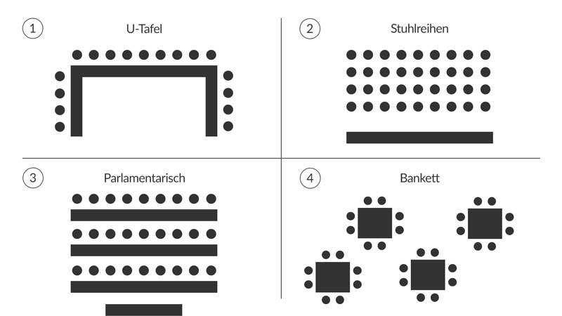

- Which seating arrangement is chosen and what purpose does it serve?
- U-Panel
- Rows of chairs
- Parliamentary
- Banquet
- Other:

Notes:

- Can all attendees move freely through the room during the event? Are all attendees visible?

- What are the rooms acoustics like?

- Does the event have to be acoustically amplified (e.g. by microphones)?
- Yes
- No
- Other:

- What is the lighting like in the room? Are additional light sources necessary? Can all attendees the podium without difficulties?

- Is there a quiet room or a retreat room near the event space?
  - Yes
  - No

  - If yes, where is it? Is it adequately signposted?

  - If yes, is it available for all attendees or only a certain subset of attendees (as a safer space)? How is this communicated?

  - If yes, what should it be equipped with?
- Water
- Seating
- Possibility to relax / pray
- Other:

  - If no, how can an alternative be arranged?

- Are there accessible toilets for people with disabilities?
- Yes
- Yes, but an attendant is required. The responsible person is

- No

If no, can a mobile accessible toilet be booked for the event?
- Yes
- No

Notes:

- Are all gender toilets available at the venue?
- Yes
- No

If no, what toilets are available for trans*, inter* and non-binary people? Can toilets be temporarily labeled as FLINTA* or all-gender toilets for the duration of the event?

Notes:

- Are the toilets adequately and clearly signposted for all participants?
- Yes
- No

Notes:

Protection during the event
In addition to the arrangement of the venue, regarding awareness it is also important to think about a safe atmosphere and climate during the event.

- Who is moderating the event?
- Moderator should be an internal member oft he organising team
- Moderator should be an independant external person

- Which aspects are important when choosing a moderator?
- Specialist knowledge of the event topic
- Professional moderation experience and techniques (are there references?)
- The social positioning of the moderator based on the event topic or the target group (e.g. specific gender, origin, disability, etc.)
- Language skills
- Other:

Notes:

- Is sensitive content addressed in the event? Is a trigger warning issued about content that may be violent, sexual or discriminatory and by whom?

- How and when during the event is the awareness concept communicated and the awareness team introduced?

Please note that there are special protection requirements for events related to Israel. For help you can contact the two lecturers of confidence against Anti-Semitism.

Awareness Team
The members of the awareness team are the point of contact for all participants and should ensure that the code of conduct is adhered to. Care should be taken to ensure that the team members can bring as many different perspectives as possible to the awareness-raising work and that the team is diverse. The reluctance to approach team members should be minimized in the case of guests who have already been discriminated against. The tasks that the awareness team should take on and the expectations and responsibilities placed on the team should be communicated to guests as precisely as possible in advance (see also Awareness Code and Handout for Awareness Persons).

- Who is part of the awareness team?

- Which status groups / group memberships / privileges exist in the awareness team?

- Who is the main point of contact in the awareness team?

- What prior knowledge do participants have?

- When does the awareness team meet to prepare?

- Is there a possibility for a consultation between the moderator(s) and the awareness team?

- How is the awareness team made visible?
- Colorful name plates
- Buttons
- Wrist bands
- Other:

- What is expected of the awareness team (e.g. proactive intervention or simply response function)?

- Who takes notice of how long for people are talking and domineering behaviors?

- How are discriminatory statements and actions recognized and addressed?

- How can participants who experience discrimination be supported?

- How can the awareness team be protected? Is security at the event necessary?

Translation and used language(s)
Some participants may have different language skill levels and might need a multilingual event format or a certain language to be able to participate in the event.

- Are the different event formats available in more than one language?
- Yes
- Depending on what information participants give during registration
- No

- Which languages are relevant for the target group / event and should be asked for / offered?
- German
- English
- German Sign Language
- Other Languages:

- What kind of translation will be offered?
- Simultaneous translation
- Multilingual moderation
- Several rooms with different languages
- Other:

- Are unknown technical terms explained (e.g. by a glossary)?
- Yes
- No

Participants and communication
The participants can have different roles and functions that can either enable or prevent communication. As an organizing team, you should therefore think about the different power relationships in the room in advance. This can also have an impact on the course of panel discussions, discussion rounds or group work.

- How will be ensured that different perspectives of different status groups and social positions are taken into account?

- How will be ensured that conversations and encounters between participants take place on eye level?
- Through a moderator who has been sensitized on this topic
- Through changing up the different formats (lecture, group work, informal conversations)
- Other:

Wrap-up
After the event is before the event. A good follow-up to the event helps to ensure the quality of the awareness concept and save the associated positive experience for the future.

- How can participants give feedback after the fact?
- Through a feedback box (anonymous)
- Per email
- Through an online feedback form (anonymous)
- Other:

- Which aspects of awareness are asked about in the feedback form?

- Does the awareness team meet up after the event?

- How is the impact of the awareness measures recorded for the planning of future events?

Other notes

