Components of an awareness strategy

A guide to creating an awareness strategy

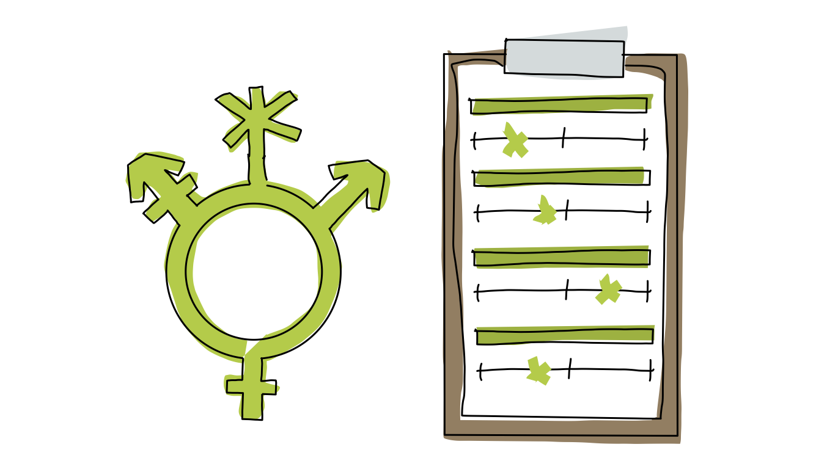
Contents
1. Goal of the awareness strategy 3
2. Information about your event for the awareness strategy 3
2.1. Overview of your event 3
2.2 Equipment for the awareness room 4
3. Awareness guidelines 4
4. The awareness team 5

1. Goal of the awareness strategy
An awareness strategy serves to bring together, organise and make accessible all relevant measures for raising awareness and preventing conflicts at events. This ensures that both the organisers and the members of the awareness team have access to the agreed rules and guidelines at all times. The awareness strategy is intended for internal use.
At this point, set out your own objectives for your awareness strategy.

2. Information about your event for the awareness strategy

In the following section you will gather all relevant information about this particular event.

2.1. Overview of your event

Every event has its own challenges and offers different organisational possibilities. The following overview provides those responsible for awareness, as well as those involved in the planning process of the event, with a summary of the most important information relevant to awareness. At the same time, it helps the event team to clearly and deliberately communicate all relevant aspects once again.
Summarise all key information here. You can find more relevant questions on this topic in the document ‚Central Questions Regarding Awareness‘ (see questions 1–24).

For example, please answer the following:
1. General information about the event (venue, date, purpose of the event, number of visitors):
2. Measures relating to accessibility (e.g. ramps, tables, accessible toilets, chairs without armrests, seating, sign language interpreters, directions, assistance with getting around):
3. Measures relating to gender sensitivity (all-gender toilets, information about pronouns, etc.):
4. Measures relating to family-friendliness (e.g. time of day, childcare provision, etc.):
5. Measures regarding image rights/privacy (e.g. stickers on name badges for those who do not wish to be photographed, etc.):

6. Transparent communication regarding the premises (e.g. usual room purpose, public accessibility, exhibitions in neighbouring rooms, acoustics, lighting conditions, seating arrangements, etc.):
7. Further important information that may be relevant:
- How do people register for your event?
- Is it an open-air or indoor event?
- Will there be food and drinks for the Awareness Team?
- How the awareness guidelines communicated to participants (e.g. by email or as a social media post)?

8. Planned schedule (including official entry times) and site maps:

2.2 Equipment for the awareness room

The provision of a safe space or quiet room is a key component of an awareness strategy. Even if it is not possible to provide an awareness team, a safe space is a facility that can offer quick and safe assistance to many people. At open-air events, an awareness tent is a good option; as a general rule, an awareness room should be made available to serve as a quiet and safe space. This space could include the following facilities:
Example - Awareness Room | Who provides the materials?

1x desk

4x chair

1x couch

1x awareness kit with consumables (e.g. tampons, dextrose, water bottle, flyers)

1x first aid kit

4x pillows

1x blanket

2x baskets with fidget toys

3. Awareness guidelines
The awareness guidelines apply to all participants at the event. To ensure they are widely known, they should be sent to all participants in advance, for example through social media or via email. The awareness guidelines should also be displayed prominently during the event, particularly in central locations such as the entrance and exit areas and in the toilet facilities.
The guidelines must be made available in at least German and English. If a translation into other languages is possible, this may also be provided to improve accessibility.
Draw up awareness guidelines for your event.

On the Awareness website, you will find an example of awareness guidelines. This may serve as a useful starting point.
4. The awareness team
Awareness persons play a key role in ensuring that the event is safe, inclusive and enjoyable for all participants. This role requires sensitivity, empathy and ongoing training.

Depending on the size of the event, the awareness team should consist of at least two but ideally four people. It is important that awareness persons always work in pairs. The team must clarify in advance how they can communicate with one another quickly and reliably (e.g. via walkie-talkies, temporary group chats or by telephone). It is also essential to clarify prior to the event who has the authority to enforce the Hausrecht at the event. This is important as it determines whether the Awareness Team can decide on exclusions themselves or whether this decision is the responsibility of the organisers.

To structure the team’s work, it is helpful to draw up a handout for awareness persons. This serves as a guide and provides an overview of the awareness team’s tasks at your event. It sets out the guiding principles of awareness work and defines where you see the boundaries of such work. This also includes specifications of joint preparation, availability during the event, and the options for support and intervention. A debriefing should also be arranged. The handout also sets out the key principles and codes of conduct, examples of how to proceed in the event of a report from an affected person, and the limits of awareness work.

Please also enclose the information listed above with the guidelines so that the team can prepare as effectively as possible. This information as well as the handout should be regarded together as a comprehensive awareness strategy.
Draw up a handout to serve as a reference for awareness persons. In addition, set out the principles governing awareness work. These principles will be appended to the handout for awareness persons.

On the website, you will find an example of guidelines for awareness persons, which can be used as a basis.

